Guidance for Topic 2 DQ 1
- I show how to do B. First, enter ft^2/tsp in P37. That the unit that we have to convert the given quantity to.

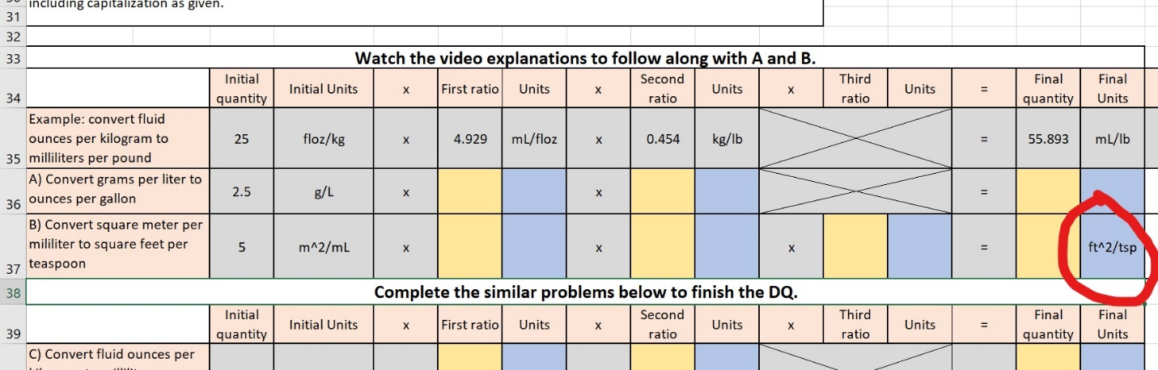

- Next, let’s convert m^2 to ft^2. Think of this as a fraction. Since m^2 is in the numerator, we have to use the factor that has m in the denominator. In F22, we see that 1 meter = 3.2808 ft.
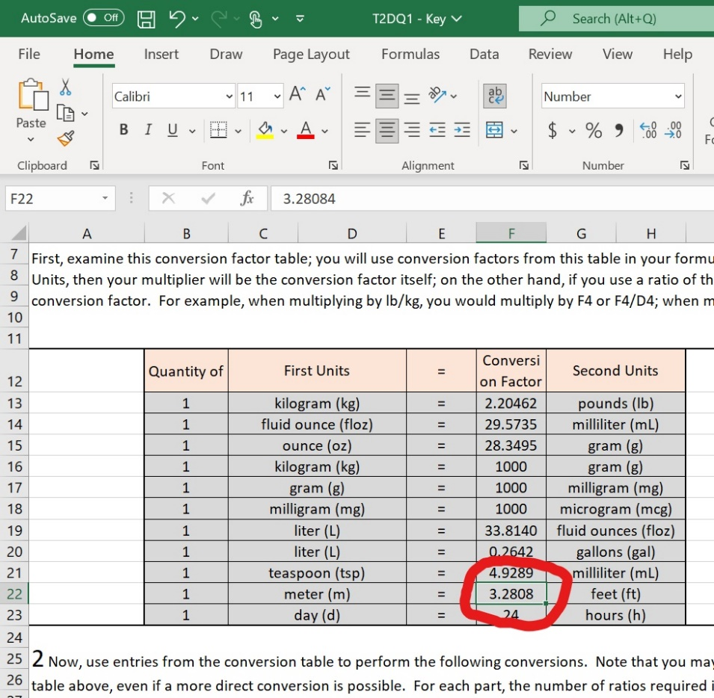
- m^2 is in the numerator, so we have to use 3.2808 ft / 1 meter so that when we make a multiplication, meter cancels each other. Note that 3.2808 ft / 1 meter = F22/B22, and m^2 means we have to multiply F22/B22 twice.

- Next, we have to convert mL to tsp. There is a conversion factor in F21.
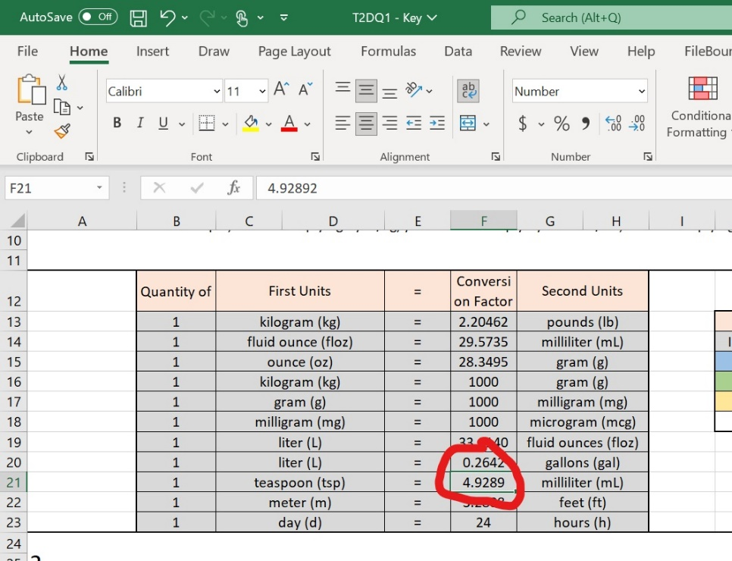

- Since mL is in the denominator, we use =4.9289 mL/ 1 tsp. which is =F21/B21 so that mL cancels each other.

- Lastly, we multiply these factors. Don’t forget to multiply the initial quantity in F37.

